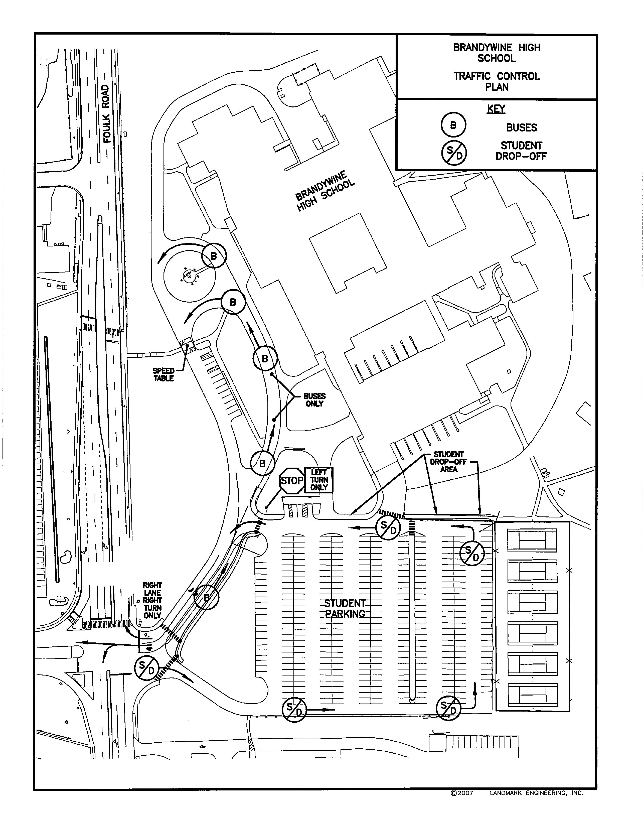
Visitor Parking
Staff
Parking

Brandywine High School
Parking Diagram
Support
Staff
Parking

